Types in python:
String type : str
Integer type: int, float, complex
Sequence type: list, tuple, range
Mapping type: dict
Set types: Set, frozenset
Boolean type: bool
Binary Types: bytes, bytearray, memoryview
None type: NoneType
Operators:
Bitwise operators:
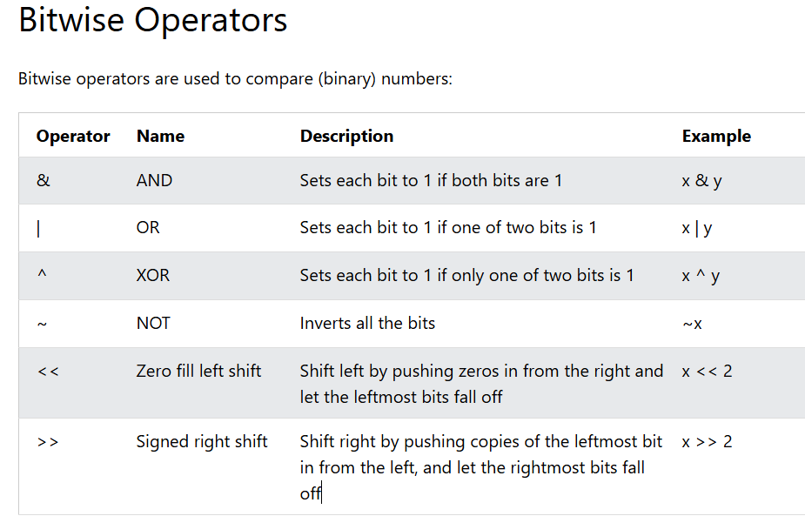
XOR (^)
x = 5
x ^= 3
print(x) value will be 6 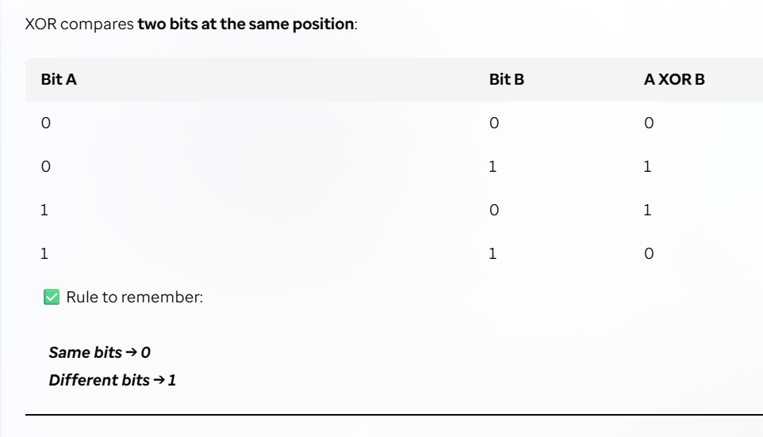
Identity Operators:
They are used to compare the objects to see if they are same objects with the same memory location or not.
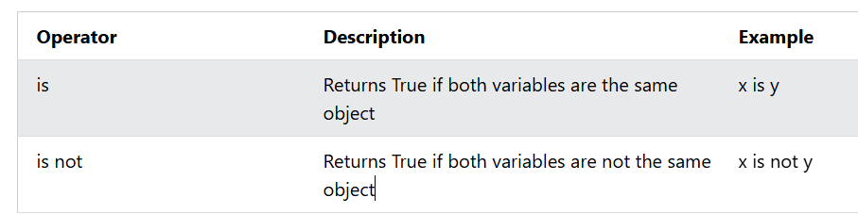
Membership Operators:
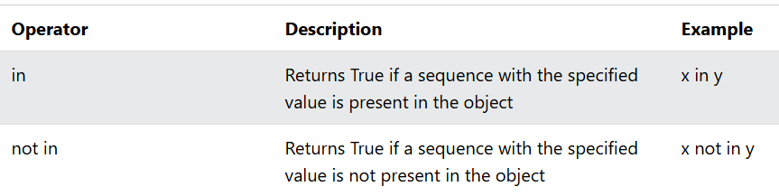

Collections:
Lists: These are ordered, changeable & allows duplicate values. A list can contain difference data types.
fruits = [‘apple’,’banana’,’guava’]

